**The Evolution and Definition of AI**

Artificial Intelligence is “the science and engineering of making intelligent machines,” as defined by computer scientist John McCarthy in 1956. But what makes a machine intelligent? And does what is considered intelligent in a machine change with new technology?

**The Definition of AI**

What is AI? Is it the computer, or the code that defines it?  AI is sometimes called Machine Intelligence, referring to the fact that the capacity for reasoning and understanding is bound by the limits of a machine and its contents. Natural Intelligence is what is exhibited by humans, bound by the limits of our cognitive functions.

AI, in its current state, could be said to be computers or programs that attempt to mimic human intelligence through displays of reasoning, learning, analyzing, and problem-solving.

Applied AI is what we use to study datasets, solve problems, test probability, and perform tasks.

**Early AI Technology –**

1. Ancient Greek god Hephaestus creating robots to assist him in his workshop
2. In 13th Century Bagdad, and inventor named AI-Jazari built a water-powered automated orchestra that worked by the means of a rotating drum
3. In the centuries that followed, automata, or moving mechanical devices made to imitate the actions of a living being

Turing Test –

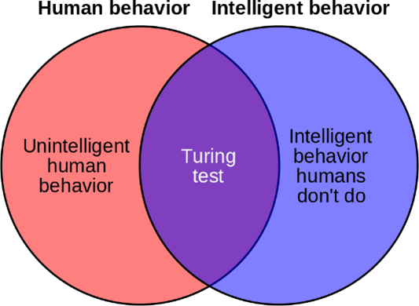Alan Turing is widely considered the father of modern AI as his proposal of The Imitation Game, which examined whether machines can think, led to his development of the Turing Test, which assesses a machine’s ability to produce intelligence or behavior indistinguishable from that of a human.

**AI Pioneers**

The list of notable contributors to the early development of AI

1. **Alan Turing** – 1912 to 1954

* Father of theoretical computer science and artificial intelligence

1. **Arthur Samuel** – 1901 to 1990

* Popularized the term “machine learning”

1. **Jerome Wiesner** – 1915 to 1994

* Selected as the chairman of JFK’s science advisory committee

1. **Oliver Selfridge** – 1926 to 2008

* Father of machine perception

1. **Claude Shannon** – 1916 to 2001

* Father of Information theory to the development of modern AI

1. **Isaac Asimov** – 1920 to 1992

* Professor of biochemistry at Boston University

1. **Ray Solomonoff** – 1926 to 2009

* The originator of machine learning AI and inventor of algorithmic probability

1. **Marvin Minsky** – 1927 to 2016

* Contributed to the proposal for the 1956 Dartmouth Summer Research Project on AI

1. **John McCarthy** – 1927 to 2011

* One of the founders of the discipline of AI

1. **Nathaniel Rochester** – 1919 to 2001

* Chief engineer of IBM’s 700 series of computers

**Infographic – AI Timeline and Famous Applications**

* It presents after the page of Key AI Concepts

**Reading: Current AI Tech and Trend-setters**

**T**here are many brilliant, motivated, interesting people in AI, here are some of the ones to watch:

**Joanna J Bryson:** professor of Ethics and Technology at the Hertie School in Berlin. Her work focuses on the impact of technology on human cooperation and AI/ICT governance.

**The Cybercode Twins:** Twin sisters America and Penelope Lopez participate in tech building competitions and hack-a-thons worldwide, are TEDx speakers, IBM Global Innovators, and all-around AI proselytizers.

**Fei-Fei Li:** The Co-director of the Stanford Human-Centered AI institute, co-founder/ chair of AI4ALL, a non-profit dedicated to fostering AI technologists, thinkers, and leaders, a researcher in AI healthcare, and former chief scientist of Artificial Intelligence & Machine Learning at Google Cloud.

**Elon Musk:** Founder of Tesla, SpaceX, and The Boring Company and co-founder of non-profit AI research company OpenAI and neurotechnology company Neuralink. Elon stays near the top of the news cycles for a variety of reasons, but putting his personal proclivities aside, his work and advocacy for AI technology are absolutely changing the way we live.

**Soumith Chintala:** Research Engineer at Facebook AI Research working to lower the barrier to AI through open-source communities and open research. He co-created PyTorch at Facebook which seeks to accelerate the path from research prototyping to production deployment.

**Andrew Ng:** Co-chair and co-founder of Coursera, Adjunct Professor at Stanford University, and former head of Baidu AI Group/ Google Brain. He founded and led the “Google-Brain” project which developed massive deep learning algorithms which resulted in the famous “Google cat” outcome.

**Tamara McCleary:** Is an AI influencer whose work and expertise in B2B and B2C marketing, social influence, and technology has brought her international recognition. She is the CEO of Thulium, a social media marketing agency that leverages AI analytics and other new technology.

**Reading: Key AI Concepts and Terminology**

### Cognitive Computing

Cognitive Computing is a computer programmed to learn like a human, but faster. It can process pre-programmed information as well as take in new information, independently interpret it, then make decisions, and take action accordingly. In this fashion it can “think” by ingesting and synthesizing information—and also re-formulate outcomes by rejecting data that does can assess and adapt; however, there is still a steep learning curve around context, which is, so far, the gulf between human-like AI decisions and humans.

### Machine Learning

Machine Learning is the part of AI that trains a machine on how to learn based on manually input features and classifiers. This is a method of analysis learned from data patterns or examples applied to learning experiences that result in unique data systems with minimal human influence. The life cycle of machine learning is to pose the problem, collect the data, train the algorithm, test the result, collect the feedback, and re-calibrate the solution using that feedback, and reapply it to the problem.

Through this cycle, the machine keeps data that is useful and disregards data that is not—the goal is to create an algorithm that will create a better algorithm. The challenge is to ensure that the source data is clean, accurate, well-labeled, and free of biased data.

Examples of Machine Learning include the self-driving Google car, recommendations from Netflix and Instagram, and fraud detection notices from your credit card.

### Deep Learning

Deep Learning is a specialized form of machine learning that uses many layers of neural networks that are arranged hierarchically—but is able to learn from data that is unstructured and unlabeled and will process and apply structure to make meaning automatically. [ Finding conflicting definitions of needing to be labeled vs unlabeled data]. The deep in deep learning refers to the layers upon layers of neural networks used in processing the data. Examples of deep learning are image and speech recognition, and natural language processing. In Machine Learning humans act as trainers for the program; in Deep Learning neural networks stand-in for the human and act as the trainer for the model.

### Neural Networks

Neural Networks attempt to mimic the way the brain works and learns with multiple nodes between the input and the output with the program building connections between those nodes. The interrelation and strength of those connections are what influence the output. The more often a specific connection is made, the stronger it becomes. Patterns are built out of the strongest data and can be compared to those of other programs in order to strengthen the network and amassing knowledge of the way that human brains do. A neural network will learn from example, so that the more examples it sees, the better it learns. And when it has enough examples and non-examples, it is able to make comparisons and learn.

### Natural Language Processing

Natural Language Processing is the interaction between humans and computers using natural human language. This is quite complex as language needs to be processed by syntax, semantics, and context. There are also the high-level abstractions of human communication to consider like sarcasm, inference, and tone.

Because human language is often ambiguous and imprecise, there are still a lot of improvements to be made in this area, however, there are plenty of NLP programs widely in use: Google Translate and Babel fish are language translators, Grammarly and Microsoft Word check grammar accuracy, Interactive Voice Response applications field customer service phone calls, and Siri, Cortana, and Alexa act as voice-driven personal assistant applications.

All NLP applications must determine a user’s intent, or what is to be accomplished. This is done through reading utterance, or the example sentences from a user that trains the program; entity, which is parsing the important details from the user’s intent like location, date, and time; context, which is determining the parameters of the whole session; and recognizing the beginning and end of the session. Along with those processes to make meaning, NLP programs must also recognize capitalization, verb tense, contractions, numeric words versus digits, single versus plural nouns, and vocabulary expansion.

**Infographic – AI Timeline and Famous Applications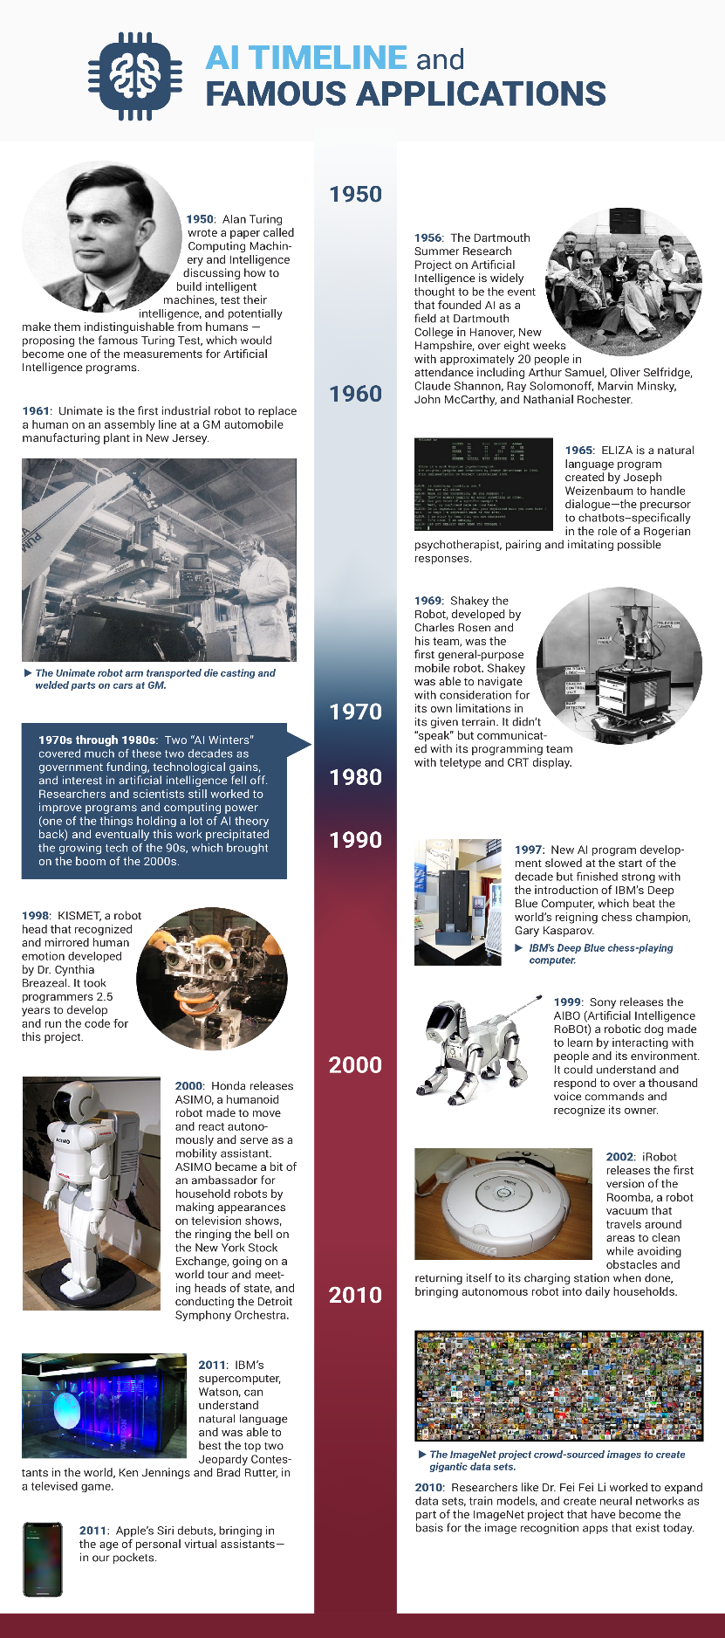­­­**

**Reading: Opportunities and Occupations in AI**

**Machine Learning Engineers** are programmers who have the software skills to apply to complex predictive models, process large data sets, use natural language processing to program machines to solve for specific tasks or to take theoretical data models and scale them to out for applications like image and speech recognition (text-to-speech), customer insight, risk management, and fraud prevention.

**Data Scientists** analyze, visualize, and model large sets of data to build and implement new machine learning models to inform and guide industry decisions—whether that is in science, marketing, media, or the law.

**AI Robotics Engineers** build and maintain robots that carry out complex tasks that bridge the gap between non-intelligent robots and AI. These robots are being used in manufacturing, security, aerospace, military, and healthcare.

A **Computer Vision Engineer** uses computer vision algorithms to process and analyze patterns in images the way a human decodes visual data. These skills are being used in jobs with companies that work with autonomous vehicles, mobile apps, sports and entertainment, manufacturing, and security.